Network Security 1 Project Rubric 4

Task: Implement Access Control Measures
Required deliverable: A report documenting:
Requirement | What You Need to Show
1. ACL Configuration | Configure at least one Access Control List (ACL) rule and document what access it allows or denies.
2. Access Control Model | Implement or demonstrate one model, such as MAC (Mandatory Access Control) or DAC (Discretionary Access Control).
3. User Access Level | Create or configure at least one user with a defined level of access and document what resources that user can access.

Suggested Report Structure
1. Objective
Explain that the objective is to control who or what can access network resources and determine what actions authorized users are permitted to perform.
2. ACL Configuration
- ACL name/number
- Source
- Destination
- Protocol/port
- Allow or deny
- Purpose of the rule
- Test result
- Screenshot/evidence
3. Access Control Model
- Model used: MAC, DAC, or another applicable model
- How the model is implemented
- Resources being protected
- How permissions are assigned
- Expected security outcome
4. User Access Level
- Username/role
- Access level
- Resources permitted
- Resources restricted
- Permissions: read/write/execute, etc.
- Test result
5. Validation
Document how you verified that the controls work:
- Attempt authorized access.
- Attempt unauthorized access.
- Record the results.
- Include screenshots or logs as evidence.

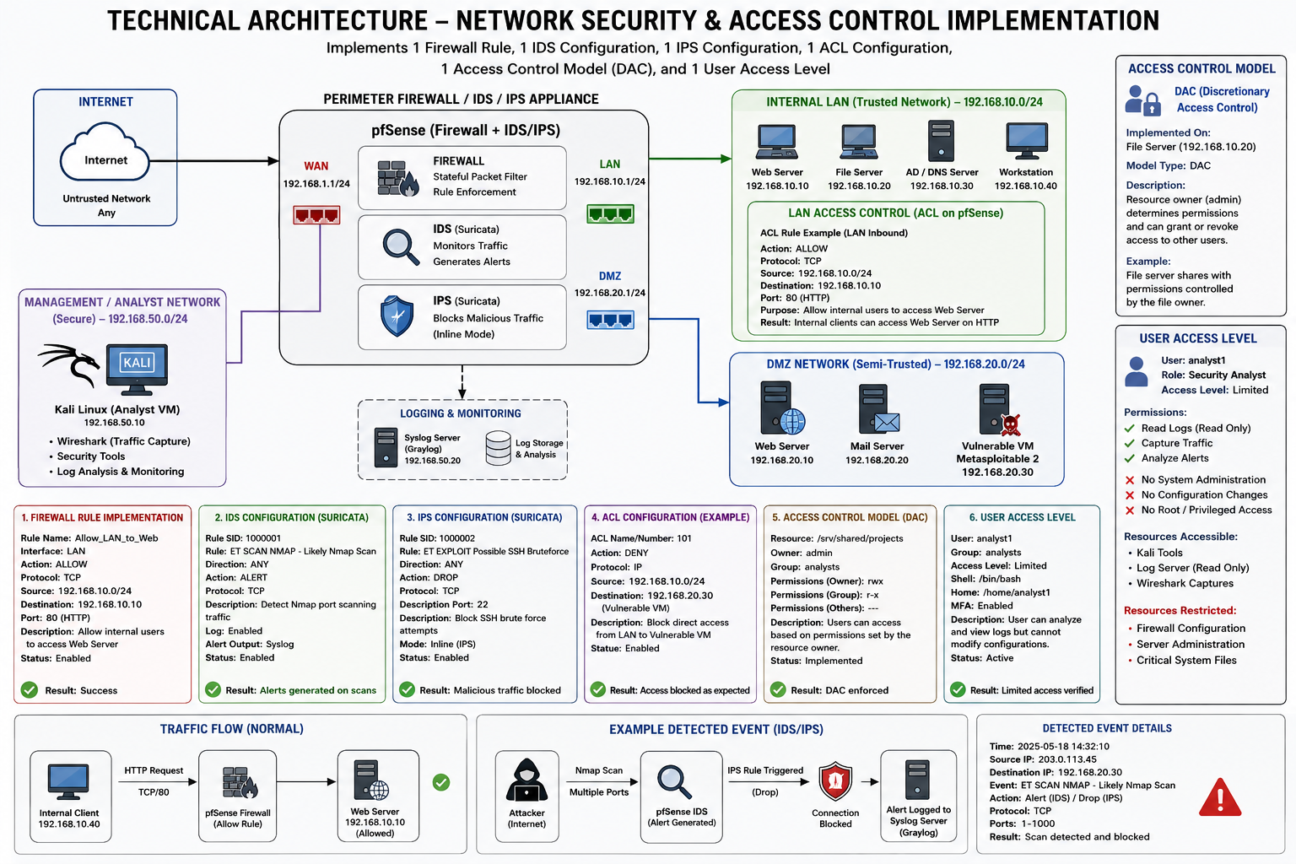
6. Conclusion
Explain how the ACL, access-control model, and user access level work together to enforce least privilege and controlled access to network resources.
For my lab, this could be demonstrated using the pfSense firewall for the ACL/network rule, a Linux-based access-control mechanism for the DAC/MAC model, and separate user permissions on the Kali or target system.

